**Objective:** Create custom exception and implement exception handling

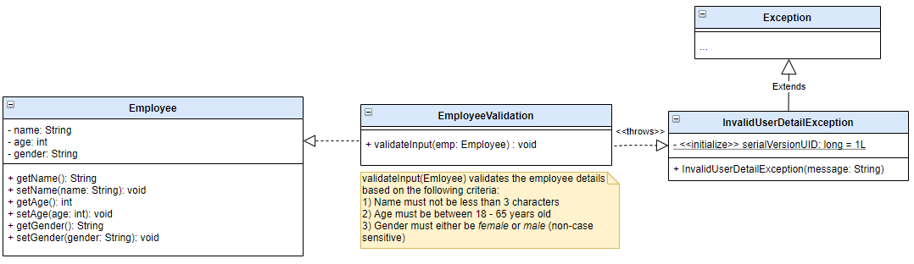

**Sample Output:** 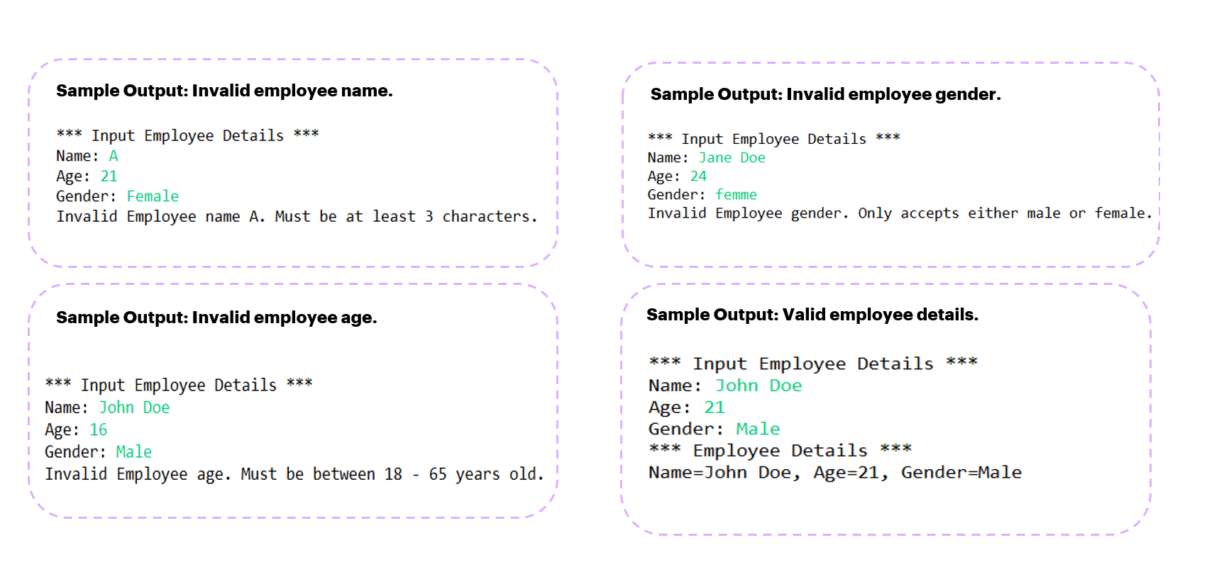

**Instructions:**

1. In your Java project, create a new package.
2. Create the following classes based on the UML Class diagram:
   * **Employee**
   * **InvalidUserDetailException**
   * **EmployeeValidation** – uses the custom **InvalidUserDetailException** class. This class contains an instance method **validateInput()**​ which will validate the employee details (name, age & gender) based on the specified criteria.
     + - If employee details are within the criteria, employee details will be outputted in the console.
       - If employee details are not within the criteria, **InvalidUserDetailException** will be thrown **with a message informing user that employee detail inputted is invalid.**
3. Create **EmployeeMain** class which will contain the **main()** method. **main() method** will allow user to input employee **name, age and gender**. Calls **validateInput()** to validate the employee details.